Table of Contents

I. Introduction..............................................................................................Page 2

---A brief look at what this project is about

II. Problem Statement...................................................................................Page 3

---A closer look at the defined problem which we intend to solve.

III. Requirements Specification....................................................................Page 4

---The limitations and restrictions on the project.

IV. Competition Strategy and Design Highlights.........................................Page 8

---How we plan to complete the course

V. Design Overview....................................................................................Page 11

---An introduction to our robot to design

VI. Mechanical Design......................... .......................................................Page 12

--Overview.........Page 12
--Drive Train.....Page 12
--Chassis...........Page 13
--Lift................Page 14
--Turnstile.......Page 15
--Level 3.........Page 17

VII. Electrical Design....................................................................................Page18

--Overview.....................................Page 18
--Cask Detection and Alignment...Page 18
--Line Following Circuitry............Page 18
--Strain Gauges.............................Page 19
--Power Systems............................Page 19
--PSoC Hardware Design.............Page 20
--PSoC Software Design...............Page 21

VIII. Alternative Designs...............................................................................Page23

---Other ideas modified, rejected, or may use in future

IX. Conclusions.............................................................................................Page25

---A summary of the project

X. APPENDIX A: Top-Down Design and Subsequent Block Diagrams...Page 26
XI. APPENDIX B: Parts List with Cost Analysis........................................Page 29
XII. APPENDIX C: PSoC Flowcharts and Diagrams...................................Page 32
XIII. APPENDIX C: References....................................................................Page 38
I. Introduction
This report contains a design for the implantation of a Robot that will compete in the 2008 IEEE Region 5 Student Robotics Contest held in Kansas City, MO. The theme of this year’s contest is Hazardous Materials (HAZMAT) handling and storage. To compete in the contest, the robot must be able to move, manipulate, and store containers according to their weight. These containers simulate “casks” which are similar to how an actual HAZMAT container would be in a warehouse environment. A cask will arrive at one end of the “warehouse” and be automatically retrieved, weighed, and stored in a bin designated for a certain weight classification without any human intervention. The use of robotic manipulation is needed in this application because handling HAZMAT is harmful to human beings.
The design of this robot required a partnership between members of the ECE and CS departments. As the ECE portion of the team, we were primarily responsible for the design and construction of the mechanical body and all of the electronic and power interfacing necessary. We will also be accountable for the lower level programming to be implemented by a PSoC (Programmable System On-Chip) micro-controller. Furthermore, we will be testing our design implementation in a simulated environment that closely matches the environment of the competition arena. To aid us in our testing efforts, we will be using the exact specifications of the competition track provided on the competition website. These specifications will be covered in the Requirements and Specifications section of the design report.
The design process utilized during the semester involved a lot of prototyping and testing to come up with workable designs. We currently have a few components of our design fabricated. These components include the wheel chassis which has omni-directional capabilities due to its wheel type and arrangement. A rotating turnstile has also been implemented, capable of rotating around a track independent of the rest of the robot frame through the use of two motors. Furthermore, working code has been contributed by the robotics team who competed in last year’s competition. This code is capable of providing instructions for the movement of two wheels. This code also implements PID (proportional, integral, derivative) control loops and optical encoder counters to keep each wheel moving at the same speed. A few changes have been made to this code to meet the needs of our design but the same overall code concept is maintained. Also, a digital weight scale prototype has been designed and tested using known weights. This scale is capable of displaying a weight in grams to an LCD with an error of +/- 10g. Finally, a PC Board has been fabricated that allows everything to be connected in one central location.
II. Problem Statement
Handling and storage of hazardous materials is presented as a growing public and professional concern. A human being’s exposure to these materials can be extremely hazardous; therefore, it is very beneficial to keep exposure to a minimum. Furthermore, proper classification and storage of these materials is vital to having a safe and clean environment for everyone. In the case of this competition, the HAZMAT is classified by weight before it is placed in its designated location. In the real world this could be taken further by classifying HAZMAT by type, size, and weight. Different types and amounts of HAZMAT require different storage methods, so this type of classification is very important. It is also very important to develop a process to perform the handling and classification of these materials without human intervention to ensure the process can be performed safely.
This competition attempts to challenge student engineers to provide a solution by developing an autonomous robot that can move through a marked track, pick up the casks—which will be weighted with sand—and place them into designated bins for each weight. This solution has great potential because it diminishes the need of staffing a warehouse full of people and manually operated forklifts as well as providing costly safety equipment to limit exposure to the HAZMAT; a completely autonomous system can be developed which relies on a robotic machine which can pick up the HAZMAT containers and place them in the correct storage locations. In the long run this could also be a cheaper alternative for many HAZMAT storage facilities (Ronan, 2007).
III. Requirements & Specifications
Our first goal in this project was to ensure we would be able to complete the task at hand—collect three casks and place them in a specified weight order. Other optional requirements have been added as a bonus in the competition. We have come up with a simple design that meets these basic requirements while still giving the best performance possible. A list of the requirements for the robotics competition is found in TABLE 3.1, modeled after examples found in the textbook Design for Electrical and Computer Engineers (Coulston, 2005). The requirements themselves were derived from the official competition rules which can be found at http://ewh.ieee.org/conf/basics2/2008-Rules-0.php (Ronan, 2007).

Contest Requirements | Engineering Requirements | Justification
Create an autonomous Robot | -No taller than 36”  -“Plan” dimensions not to exceed 16”x16”  -Weigh < 50 lbs | Robot size and weight is feasible for a small-scale competition.
Provide emergency stop | -Visible red “kill” switch placed in accessible location on top surface. | “Kill” switch is needed to stop the robot from going haywire. Red is very easy to see.
Do not leave the course or remove casks from the course. | -Use light sensors to utilize provided ¾” black lines painted on the track as a guide. | The robot can utilize a program to stay on the black lines as well as keep from pushing the casks off the board while trying to pick them up.
Place casks in the 3 numbered boxes in the correct specified weight order. | -Lift and weigh the casks.  -Make robot pre-programmable to carry different combinations of routines.  -Weights are 63g, 126g, & 189g.  -Lifting mechanism must accommodate the 3.625” region of can between the two side boards of the casks. | By weighing the casks a pre-determined program can then take that information and put it to action by placing the weights in the correct order. The casks cannot fall off the robot or the routine will be messed up.
Perform task in under 3 minutes. | -Make robot able to carry around the max required weight while still maintaining speed. Worse case is a full soup can.  -Needs to be able to turn a 6” radius  -Eliminate inefficient operation. | Heavy loading can slow down the robot so ensuring the robot is capable of handling the heaviest weight will ensure it can complete the task. Inefficient or wasteful operation adds time to the run and less time gives more point deduction.
Place casks in the three colored bins red, green, and yellow according to weight classification. | -Make robot able to see and interpret the following Rust-Oleum colors:  Sunrise Red, 7762-830  Hunter Green, 7738-830  Sunburst Yellow, 7747-830  -Make robot less dependent on lighting and texture.  -Lighting is a combination of incandescent (chandeliers and “cans”) and fluorescent.  -Lift cask at least 0.25” off the board  -Front of robot must not be greater than 10” wide, 6” tall, or 6” deep. | The robot needs to see these exact colors but we do not know if they will be using wood or exactly what material. Therefore, we cannot depend on texture. Lighting conditions are expected to be varying especially with people walking around and casting shadows. Robot needs to be able to lift the cask and fit it into the bins, therefore, it’s dimensions must accommodate for that.
Display the weight of each cask in even grams. | -Use a display capable of displaying 0.75” tall characters.  -Display the weights in order of pick up from top to bottom for whole duration.  -Extreme accuracy not important  OPTIONAL | The size of the characters makes them readable and the display order provides a way to see in what order the casks were picked up. This is for bonus point deductions.
Remote starting with non-audible means. | -Use wireless method to start up the robot  OPTIONAL | This gives bonus points plus adds to the autonomous aspect of the robot.

TABLE 3.1 (Ronan, 2007)
The competition will consist of 3 rounds where all of the criteria in Table 3.1 will be tested with a set of rules specified on the competition website. First and foremost, the competition course consists of two components, the track and the casks. The track, cask and bin images and specifications can be seen in FIGURE 3.1, 3.2, 3.3, 3.4, 3.5, 3.6.
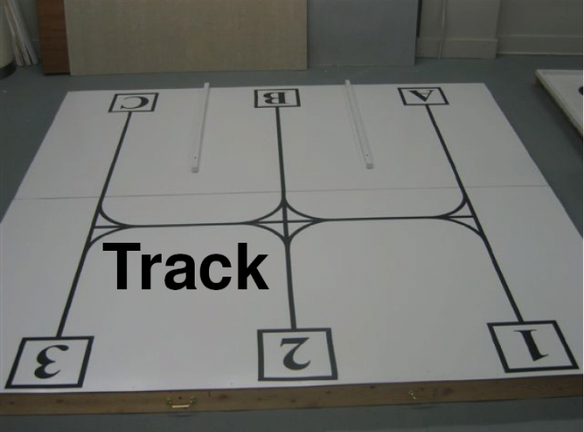
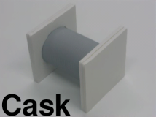
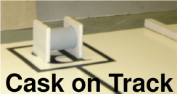
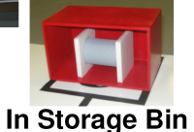
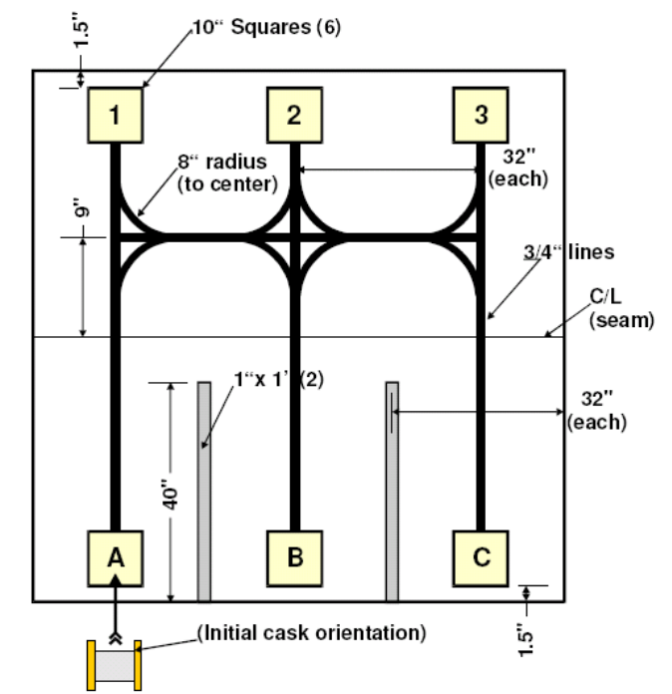
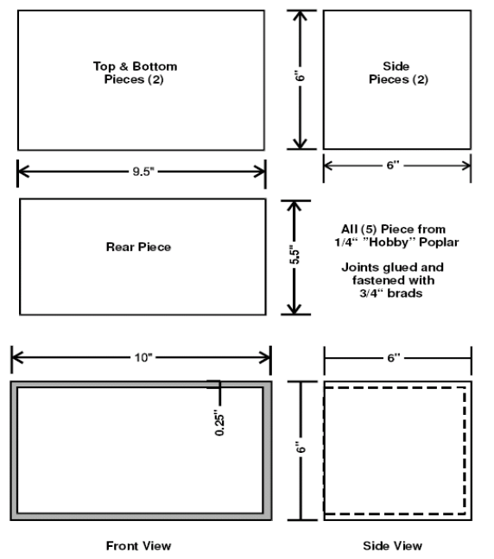
FIGURE 3.1 (Ronan, 3007) FIGURE 3.2 (Ronan, 2007)

FIGURE 3.3 (Ronan, 2007) FIGURE 3.4 (Ronan, 2007)
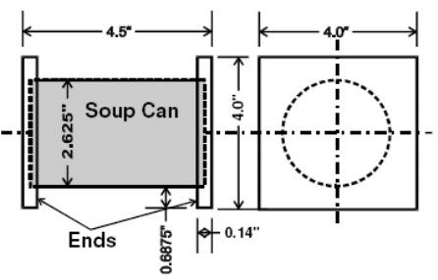
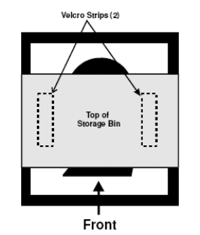
FIGURE 3.5 (Ronan, 2007) FIGURE 3.6 (Ronan, 2007)
The above figures serve as a guideline for building a test set-up to develop a working robot that is able to place well in the competition.
The first and second rounds of the competition will consist of correctly placing the casks in their given locations. Teams may choose to sit out for either of the first two rounds. The top ten teams of these rounds will move on to the third round where another element is added to increase the difficulty. For this round, the weights will be assigned to a colored bin before the round begins. The bin positions will however be unknown before the start of the round. Therefore, the robot must be able to detect different colors to determine the correct location for cask placement.
The competition rounds are based on a scoring system where points are deducted for successful operation. Each team will start with 300 points and 3 min on the clock. For the first two rounds, 50 points is deducted for each correct cask placement “anywhere” on the designated numbered square. An, additional 50 points is deducted for two successful placements and 100 points is deducted for all three. Round three, however only allows a successful placement if the cask is placed entirely inside the storage bins. Only 25 points will be given if the cask is only partially inside a bin. Teams can receive 15 bonus points for displaying the weights in their picked up order using 0.75” characters and 10 bonus points for utilizing a non-audible remote start. Each second it takes to complete the round will be added to the final point tally. Teams with the lowest points win. Finally, a team can be disqualified if the robot goes off the track, a cask leaves the track, a cask is damaged, or a storage bin is moved or damaged.
IV. Competition Strategy and Design Highlights
After an initial meeting with Dr. Weinberg and Dr. Engel, it was very apparent that not only was it expected of us to complete all of the requirements of the competition, but to win. To do so, we knew we would have to embark on some complicated designs in order to put us on the same playing field as other big schools. Our first design to implement strategy is the use a PSoC to do all of the lower level commands. The PSoC is used as a low level method of control for the robot. For example, when my brain tells me to walk I do not have to consciously monitor every movement to make myself walk. Walking can be considered a result of impulses sent from the brain that I am not consciously aware of at all times. This is very similar to the concept that we are using with the PSoC. Once the PSoC is told to move the robot by the XBC (X-Bot Controller), it will proceed to move on it’s own without the aid of the XBC.
This will allow for faster processing, give the XBC more room to react to incoming sensory data and calculate the next move. Furthermore, the PSoC is implementing its own PID control to ensure the wheels are moving the same speeds, as well as measuring out the distance traveled. PSoC will be able to use both the distance measurement and the light sensors to tell when it is supposed to stop movement.
Aside from just thinking fast, we also needed a robot which could move fast. It was desired to eliminate all unnecessary movements the robot would take from one side of the course to the other. To fulfill this desire, an omnidirectional drive train has been designed to allow for movement in any direction at any time depending upon the speed and direction of each of four independently powered and controlled transwheels. A turnstile to revolve the lift around the body of the robot has also been developed. The combination of the turnstile and drive train completely eliminates the need for the robot to revolve at all during the run of the course. As opposed to turning to switch movements of front and back to sideways, the robot simply turns the second set of wheels. This, the orientation of the robot is comparison to the world never changes. This greatly reduces its confusion as to where it is at on a global scale at any given time. The diameter of the wheel was also increased from last year’s 2.5” to 4” such that more distance is traveled with each revolution of the motors.
Another step in the direction of victory is the ability for the robot to follow guide lines painted on the track. Videos of previous line following robots in which very choppy, or “bang-bang” movements caused a robot to be incredibly slow prevented last year’s team from even considering traditional line following. Instead, they used a system of pre-determined distances and movements, or dead reckoning, to maneuver the course. However, a member of last year’s team informed us that the quickest robots at the competition were those that didn’t have to worry about placement or orientation, rather, they followed lines based on intersection recognition and calculated paths. He highly recommended we use line following if we wanted to compete, and so we are.
In order to properly line follow, many sensors are needed. This enables the robot to smoothly correct itself depending upon which sensor sees the line. The further away from the center the line is seen, the quicker the robot tries to correct itself. The more sensors watching for lines, the more dampened this correction can be. Because of our limited port space, a system of multiplexing and encoding has been developed to read many sensors and recognize line intersections. Furthermore, two sets of wheels will allow the use of line-following techniques that could only be implemented with four wheels. Instead of adjusting the speed of one wheel versus the other, we can simply turn the other set of wheels in one direction yielding a curving motion back onto the line. Even if the robot is turned at an angle with reference to the line, the extra set of wheels can turn in opposite directions until the robot is straight again. With a four wheel set-up we will have our light sensors placed in a cross pattern allowing us to detect intersections when all of the light sensors are lit up.
Another design feature would be the implementation of strain gages as a means for weighing the casks. This technique is simple to implement and works very will with the PSoC. It is also easy to integrate onto a lifting mechanism. Also, our utilization of the Gameboy XBC platform is useful because it serves as an easy to use high-level control interface for the robot. The XBC supports a variety of different sensor configurations to include a color camera and built-in color detection through visual processing software. This camera will affectively detect the colors of the storage bins by simply scanning for their locations at the start of the round. The camera may also be used as a backup plan in case the PSoC can no longer detect the lines due to the robot maneuvering completely off of them.
A power system has also been incorporated to account for the amount or power being drawn by so many motors and sensors. A higher than needed voltage is regulated down to provide more current and longer battery life. Appropriately rated batteries are also being used as opposed to last year, where batteries of different capacitances were put in series. This can greatly reduce the life cycle of the battery and lower its charge capabilities.
Lastly, in order to be able to control any of the four wheels at any time and read multiple sensors, two PSoCs will be in communication with each other. This additional port space will greatly reduce the need for switching relays and noisy data readings. It is our belief that with all of these clever designs, our robot will be able to compete with the best of the other schools and do very well in the competition.
V. Design Overview
The most basic goal of our design is to adequately fulfill all of the desired requirements of the competition. To do so, we are creating a robot with control architecture of mixed reactive and deliberative control meaning that while some of the robot’s movements are pre-determined based on a closed world assumption, many others are the response to sensory data input. Level zero of this design can be seen as a single box with inputs of sensory data from the environment and human interface and outputs of movement and audio/visual response. This box can then be broken down into two distinct sectors: the brain and the body, seen in FIGURE 5.1.
Although the brain directly tells the body what to do and how to do it, there is a feedback path from the body to the brain such that the brain can consider environmental input from sensors and react accordingly—often times by updating the body commands. | 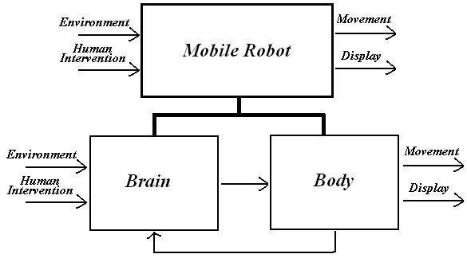  FIGURE 5.1
As a multi-disciplinary team, the design and progress of the robot is shared between students of the CS and ECE departments. The ECE team is responsible for the body of the robot, including mechanical and electrical design, while the CS team is responsible for the upper level commands of the brain. The lower level coding is shared between both teams, but has been primarily designed by the ECE team. For this purpose, the lower level commands performed by the PSoC will be included in the electrical sections of the body design. It is then possible to further break down the design of the robot body into individual sections of which there are several sub-categories and components, shown in FIGURE 8.1 of Appendix A. The first of these splits is the division of the body into mechanical and electrical components.
VI. Mechanical Design
The mechanics of the robot are responsible for one primary thing: moving the casks from their starting positions to bins on the opposing side of the track. To do so, three distinct levels of the robot are to be constructed. The lower level includes the drive train and chassis which is responsible for moving the robot about the track. The second level includes the lift and turnstile which are responsible for raising and lowering casks. And the third and top level of the robot is a mounting place for all of the circuitry and controllers which were not required to be placed elsewhere on the robot.
Drive Train
The drive train determines the level of mobility of the robot. Our design consists of four independently controlled omni-directional wheels. To accomplish this, each wheel is
mounted to a 175 RPM motor with a 50:1 internal gear reduction through the use of a wheel mounting hub and other custom fabrication. This design is seen in FIGURE 6.1. The bronze sleeve is epoxied | 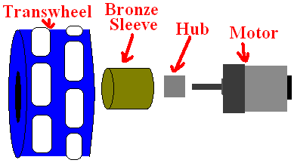  FIGURE 6.1
to both the wheel and the hub and serves as a coupler between the two. The hub is then bolted to the shaft of the motor. The four wheels are then placed in the shape of a plus sign which can be seen in FIGURE 6.2. With this configuration, the robot has the ability to move in any direction at any given time depending upon the speed of each wheel. To move in forward and back or left and right, the two motors powering the wheels parallel to the line of desired movement are activated while the other two wheels allow perpendicular movement due to the set or rollers around the outside of each wheel.
This special type of wheel is known as a double cat-trak transwheel. The double portion refers to the two sets of rollers, and the cat-trak signifies that the rollers are coated in polyurethane to promote grip. Each wheel is four inches in diameter and two inches in width. With the drive train designed, it is necessary to create a chassis to hold it all together. | 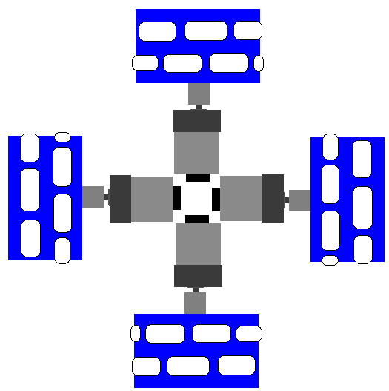  FIGURE 6.2
Chassis
With each wheel weighing over a half of a pound and each motor around a quarter of a pound, it is desired to reduce the overall weight of the robot by creating a practical chassis with minimal bulky parts composed primarily of aluminum due to its combination of strength and light weight. The inner part of the chassis to mount the motors will for the shape of a
pound sign while an outer octagon wraps around the inner chassis to protect the wheels from collision. It is also desired to mount the motors as close together as possible to reduce the overall dimensions of the robot. In addition, a balance is needed to ensure proper omnidirectionability. The described design does just that. As seen in FIGURE 6.3 | 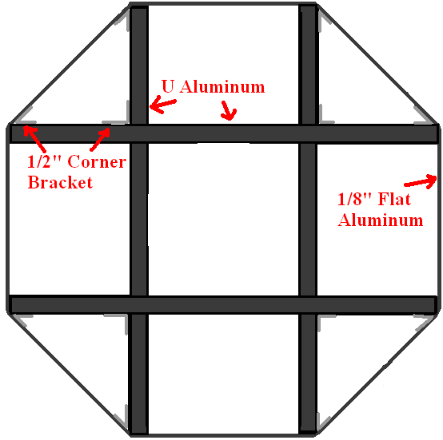  FIGURE 6.3

The drive train is then mounted to the chassis by four motor mounts specifically designed for the used motors. The combination of these two sections then completes level one of the robot and can be seen in a composite design sketch in FIGURE 6.4. The resultant is a strong, balanced, omnidirectional frame easily capable of maneuvering the course.
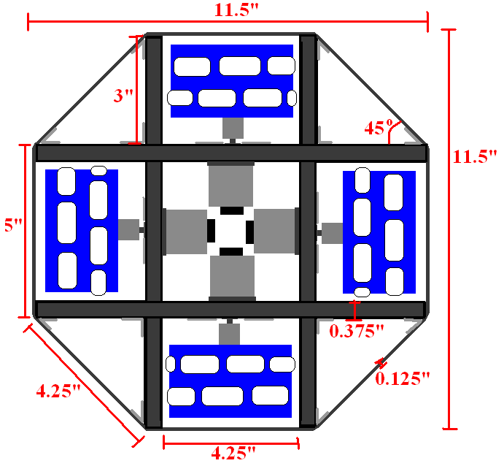
FIGURE 6.4
Lift
Initially, we were unsure of the maximum amount of weight that the lift needed to be able to pick up. Although the actual weights of the casks have been given, it was still desired to created a lift capable of picking up far greater than then maximum cask weight for two reasons. The first of which is obvious—lifting the casks is overall purpose of the robot, so it should not struggle at doing so. The second and less obvious reason also coincides with the first—to slow down the lifting speed. The speed of the motor is determined by a pulse width modulated signal. This period of this square wave is controlled by the robot controller. As the frequency of the pulse is decreased, the average voltage being applied to the motor is also decreased and it slows down. However, decreasing the voltage to decrease the speed will inevitably decrease the power as well. To account for this, an external gear box is to be constructed in addition to the internal gear reduction of the lift motor, which is identical to those used in the drive train.
Under no load and at full power, the motor is turning at 175 RPM which is about 2.92 revolutions per second. This can further be translated to 1050º per second. Keeping in mind that the lift will only need to rotate about 30º to lift the cask off of the ground while keeping it low enough to be placed in a bin, this value needs to be lowered substantially. Using lego parts to construct a gear box, an external reduction of 25:1 can easily be achieved by two 5:1 reductions in series. This external reduction would then lower the speed of the lift to 42º per second, or one 0.12 revolutions per second (7 RPM). This gear reduction will also increase the torque by a factor of 25 upping the current 7.1kg-cm of torque for the motor to 177.5 kg-cm of torque. With this added power boost, the speed can further be slowed by pulse width modulation without the fear of loosing too much power.
The lift itself will be a platform lowered from the lift motor and gear box which are mounted to the turnstile atop of the chassis. The added power of the gear box will also combat the loss of power due to the moment created from the length of this lift arm. A platform is used to pick up the cask such that strain gauges can be easily mounted. With these gauges mounted directly to the lift platform, there is no un-linearity in the conversion of the output of the Wheatstone bridge monitoring the gauges to the desired mass of the cask being lifted.
Turnstile
The turnstile is actually an unnecessary feature for the overall purpose of the robot because of its omnidirectional capabilities; however, the ability to rotate the casks around the robot as it moves from one side of the track to the other will not only save the time it would have taken for the robot to rotate, but also the error in rotation which is bound to happen at some point in the run. Using sensors to control the movement of the turnstile makes it more accurate than the robot’s rotation. There are other practical applications for the turnstile such as a search and rescue robot in which various cameras or sensors are placed on the robot for it to search around itself as it moves in any given direction.
It is also desired that only the lift be rotated around the robot and that the upper level remain stationary. This means that the rotation is limited by the wires and control lines going to the lift and turnstile motors and sensors. To accomplish this, the lift is mounted to a frame that rotates around a track using track runners. This frame is powered by the same motor used in the lift and drive train designs. It is attached to a large wheel which drives the turnstile. The track runners keep the frame from running off of the track, thereby ensuring its rotational motion. Guide posts attached to the floor and the ceiling of the second level hold the frame down on the wooden platform floor to prevent drive wheel slippage. The completed turnstile design is seen in FIGURE 6.5. As shown, each individual track runner is adjustable such that the resistance of the frame to turn can be increased or decreased depending upon the intended use.
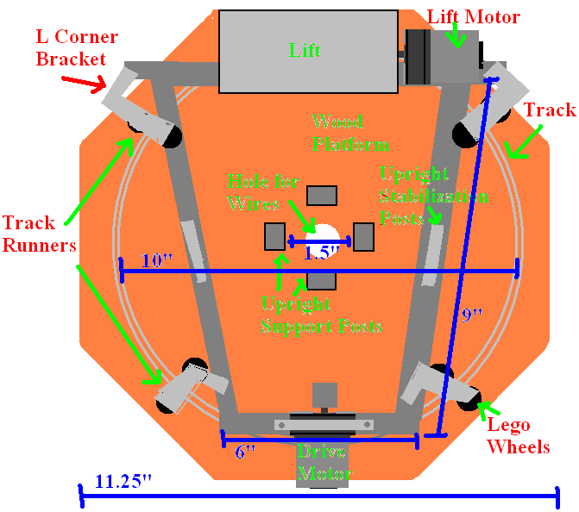
FIGURE 6.5
Level Three
The top level of the robot only contains one moveable part—an HS-422 standard servo. The camera will then be mounted to this servo which can rotate to specific positions. From these positions, the camera can check for the color of the bins such that the XBC can determine where to take which cask. Aside from the mounting of this servo, the top level was serve as a base in which all of the other circuitry as well as the XBC and PSoCs can be mounted for easy accessibility. Some other components such as the line-following circuit are to me mounted else where on the robot—under the chassis in the case of the mentioned line-following circuit—depending upon their purpose.
VII. Electrical Design
There are many different aspects of the electrical design to consider. The main sub categories are the sensory circuits, the power systems, and the PSoC. Sub categories include cask detection, line following circuitry, strain gauges, power regulation and charging, and the hardware and software PSoC design.
Cask Detection and Alignment
One of our initial concerns was how to make sure the robot is in line with the cask when it goes to pick it up. If the lift and cask are misaligned, the lift will fail to pick up the cask and may actually flip the cask on its side, making it impossible to get. To solve this, a group infrared range finding sensors will be placed on the lift outlining the shape of the cask. Depending upon the returned value from these sensors, the robot will know if it needs to move to the left or two the right as it approaches the cask. This sideways movement would not be possible without the current drive train design. There is no external circuitry needed for these sensors, they can be read directly by the XBC. Large values indicate close proximity while small values indicated an object is far away.
Line Following Circuitry
One of the biggest electrical challenges will be to create a perfectly working line following circuit. We have designed a cross shape of two arrays of sensors. There will be at least 5 sensors in each array; more may be added if port space is available. Infrared reflection sensors will be used to determine the presence or absence of the black line. Values from multiple sensors are then encoded into a few bytes of information to reduce the necessary ports. To detect intersections for accurate path planning, a separate digital circuit is to be created using a custom truth table and k-map to determine the desired out come. The outer most four sensors will be monitored, and depending upon which of these for sensors is lit, this circuit will out put a 00, 01, 10, 11 to let the XBC know which intersection it is at. The two arrays of sensors will also be multiplexed such that only one array is being read at a time aside from the four outer most sensors just described. This circuitry would reduce the necessary port space from 9 to 5, seen as FIGURE 10.2 of APPENDIX A. Of course, as more sensors are added, more ports will need to be used, but only one extra byte of information is needed for double the current amount of sensors, so there is a high probability that more will be added in the future.
Strain Gauges
The purpose of the strain gauges is to weigh each cask to determine which is the lightest, medium, and heaviest. Because this is implemented entirely by the PSoC, it will be discussed in detail during the overview of the PSoC design.
Power Systems
To ensure there is enough power for all of our motors and sensors, we have a designed a power regulation system to run from a central 12 volt source composed of a NiMH 7.2 V 2800mAh battery back in series with 4 AA NiMH 1.25 V 2800mAh cells. The total series voltage is 12.2 volts. Much like last year’s robot, our robot will have two battery packs in parallel to maintain balance and extend the run time. Slide switches will also be in series with each of the battery packs to allow easy cut of from the rest of the circuitry. A single large, red “kill switch” is then placed between both battery packs and the rest of the circuitry to instantaneously shut off everything in case of unpredictable behavior. The 12 volts is then regulated to 9 volts through the use of an LM317 adjustable voltage regulator. The batteries can be charged using a 12 V wall outlet transformer with a current equal to their combined capacitance of 5600 amps. For safety purposes, the charging current will not exceed 2 amps. This circuit is seen as a block diagram in FIGURE 10.3 of APPENDIX A.
PSoC Hardware Design
As stated previously, the PSoC is used as low level control for the robot and as a digital weight scale for classifying the casks. The PSoC was chosen over other microcontrollers because of its programmable hardware configuration capabilities. This microcontroller has built-in memory so external RAM does not need to be interfaced. Also, digital versions of analog components can be created using the PSoC configuration software. This gives the PSoC the advantage of having many different applications. For our purposes we will be using 4 16-bit counters, 4 Pulse-Width Modulators, 2 16-bit Timers, 2 UARTs, 1 RS-232 Transmitter, 1 Instrumentation Amplifier, and 1 14-bit ADC. A hierarchy of the built-in configuration of both PSoCs can be found in the Appendix.
The PSoC will be interfacing with many different pieces of hardware in this design. This includes the XBC, 6 motor controller IC chips, 4 optical encoders, 9 light sensors, a serial LCD, and a digital weight scale. To interface with all of this hardware serial communication and direct port connections is used. The serial communication uses the RS-232 standard and takes place between both PSoCs and the XBC, between both PSoCs, and to the LCD display. The Low-Level Hardware Connection Hierarchy in the Appendix shows more detail as to what ports are used in these connections.
To allow ease of connection, a PC board was designed to allow a central connection point for the wheel motors, the optical encoders, both PSoCs, the turnstile motors, and the 7.2V motor power supply. A modified schematic detailing all of the connections to this PC board exists in the Appendix. To aid in the understanding of this schematic, it was chosen to just label the pin connections instead of connecting wires since the wire connections created a confusing mess. This schematic details all of the existing plug connections, the motor controller IC connections, and the PSoC port connections. Any unassigned ports in this schematic can be reserved for testing purposes or further design implementations. Pictures of the PSoC and the PC board including labels have also been provided in the Appendix.
The final PSoC hardware design is the digital weight scale. The PSoC controlling the East and West motors will contain the weight scale since those wheels will be used to move the PSoC toward the casks. This was chosen to make the code design simpler. FIGURE 7.1 provides a simple schematic showing the basic design concept of the digital weight scale implementation. The strain gages form what is called a wheat-stone bridge consisting of four 200 Ohm resistors. On two ends of the bridge power and ground is connected. The other two ends are sent out to an instrumentation amplifier where the voltage difference is amplified and converted by the ADC on the PSoC. The Appendix contains an actual picture of the strain gages that will be used for the design.

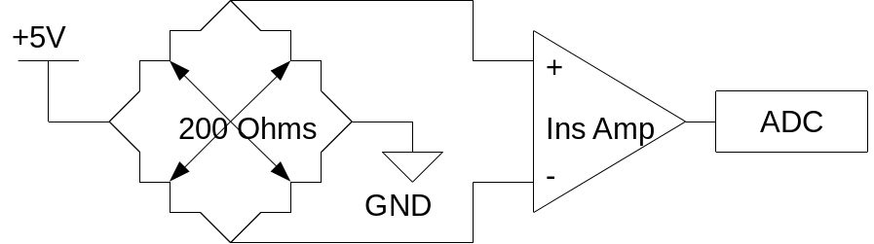
FIGURE 7.1
PSoC Software Design
The PSoC software implementation relies on the use of an ISR (interrupt service routine) that flips consecutive bits of an 8 bit variable called Timeslot. Each consecutive bit flipped represents an amount of time that has passed by. For example, the first bit takes 10ms to flip, the send takes 20ms, and the third takes 40ms. These times are set by the internal timer implemented in the PSoC configuration. The ISR allows the main program to poll for events of interest.
The PSoC main program starts off by initializing all of the built-in components needed for the design. Next, the motors are stopped, the PID variables are set, the wheel structure is initialized, and the command structure is initialized. Now the ISR polling loop begins. Every 10ms the program checks if a byte has received. If a byte has been received it is determined if this byte is a command or a data bye. Command bytes tell the PSoC what to do and data bytes tell the PSoC how many TICs to move. The received byte is then processed.
This polling interval also checks for any changes in the light sensors. An algorithm for adjustments of the robot due to light sensor activity will be implemented here. We have determined that if all light sensors are lit up, then the robot must stop. Since each set of wheels has it’s own PSoC, when one PSoC has all light sensors lit up it must send a signal out to the other PSoC to notify it that this has occurred. The PSoC will used this notification to stop if its light sensors light up as well. It is desired to be able to send the other PSoC information through the serial interface but it is not known how well this will work. Further details on the operation of the code is detailed in flow-charts contained in the Appendix.
An important aspect of the XBC communication with the PSoC is the utilization of a command byte to instruct the PSoC. This command word consists of 5 different commands. They are byte type, motion type, velocity, direction, and distance mode. The byte type is used to distinguish between a command or a data word. An alternative to this would be to check a port for a logic high to tell when a byte is coming in from the XBC. Just in case this is needed, 2 ports have been reserved on each PSoC labeled RX_ENBL and TX_ENBL. The motion type will distinguish between translational and rotational motion. The velocity command takes up two bits and it consists of 4 different velocity settings 0,1,2, or 3 with 0 meaning a zero velocity. The direction command tells the PSoC to move forward or backward for translational movement and clockwise or counter clockwise for rotational movement. Finally, distance mode will change how the number of TICS is measured affecting the resolution of movement.
VIII. Alternative Designs
There have been many other design possibilities which were modified or rejected along the course of this project. The first design for the drive train was incredibly similar to last year’s robot. It consisted of two powered unidirectional wheels and two or more smaller, unpowered omnidirectional wheels to allow rotation. After a deliberation between all four members of the team, our current design was decided upon to improve on last year’s design and allow for movement in any direction without rotation. Similar movement could also be achieved using three trans wheels arranged in a triangle as opposed to four; however, this would greatly complicated the driving commands and decrease the stability of the robot. In keeping up with our strategy of back, forth, and side to side movements, the most logical choice is the current design of four transwheels arranged in a square.
Another very significant design change with the rejection of the double lift concept shown in FIGURE 8.1. This design called for two independent lifts, one on either end of the
robot, so that two casks could be picked up and compared in order to know what the weight of each was depending upon the relationship of the two. This would also save a lot of time that would be | 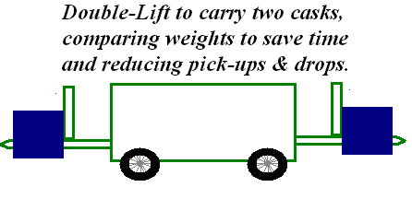FIGURE 8.1
taken picking up one cask, recording the weight, and then setting it down to pick up another in order to compare the two to determine which was the lightest, medium, and heaviest. This constant picking up and setting down of the casks would also increase the probability of failure due to misalignment of the lift and the cask. This design was quickly rejected with the release of the new rules in early October where the weights of each cask are given. Whether the light, medium, or heavy cask has been picked up can now be determined by simply lifting one cask and weighing it. Two lifts would also have required twice the sensory and mechanics.
After further consideration, without or with the second lift, the movements of the robot would be very similar to that of the originally designed drive train: forward, backward, and rotating to turn. This motion does not justify the need of the updated omnidirectionable drive train, so a new and bold idea was created—revolve the lift around the body such that the robot doesn’t have to rotate. Although this may seem overly-complex, the amount of time potentially saved by doing such could prove crucial in the actual competition, and our goal is to win. Besides, without risk, there would be very little advancement.
Another significant change in design was in the control of the motors. We have always been very concerned with the available digital blocks and physical ports on the PSoC, and both Dr. Engel and Dr. Weinberg have stated that we should control the motors and read most of the sensors by the PSoC directly because it is able to process faster than the XBC due to the amount of libraries embedded in the XBC. Because our robot would never need to rotate, only one set of wheels should ever need to be powered at any time. Although this would have killed the ability of omnidirectional movement, it would still allow for lateral movement without rotation. A four pole single throw relay was to be used to switch between the two sets of wheels, depending upon which direction of movement was desired. Similar relays would also need to be switched between encoders as well. This idea was not the best, but we didn’t see any other option until Dr. Engel informed us that we could use two PSoCs to spread out the available ports. Each PSoC would then need to talk to the other.
There were a few design alternatives which were not used due to limitations in built-in configurations and port availability. One such design involved having both sets of wheels on one PSoC and placing just the digital weight scale on the other PSoC. This would not work because the PSoC did not have enough digital ports for the built-in configuration. Also, the PSoC did not have enough hardware ports to connect all 9 light sensors. To allow all 9 sensors to be connected we would have needed to multiplex the 9 sensors down to 4 ports on the PSoC. Another feasible alternative is to use the XBC to control the wheels instead of the PSoC. This alternative has come forth because of the added complexity of the PSoC controlling all four wheels. Our design team has limited knowledge of programming the PSoC which is hindering the development process. These alternatives will be looked at further during the testing, and building of the robot.
IX. Conclusions
When it comes to dangerous situations, using a robot is more practical than a human; there is no arguing with that. Our designs for this robot can be used in a wide variety of other applications as well, so they are not only limited to the current project. Our methods for movement and cask placement are very unique and should give us a good edge over the competition. The cooperation between the CS team and our portion of the team is a great example of multidisciplinary projects in the real world. The design and implementation of two PSoCs is also an incredible way to increase port space while cutting down on processing time and memory usage. As far as strategy goes, line following in combination with the drive train design has incredible potential for the robot to run a perfect course and for many other applications outside of the competition as well. Over all, our design and strategy of the robot is far superior to anything we would have ever thought of at the beginning of this project. We are sure that this robot will be a top contender in the 2008 IEEE Competition.
X. APPENDIX A: Top-Down Design and Subsequent Block Diagrams
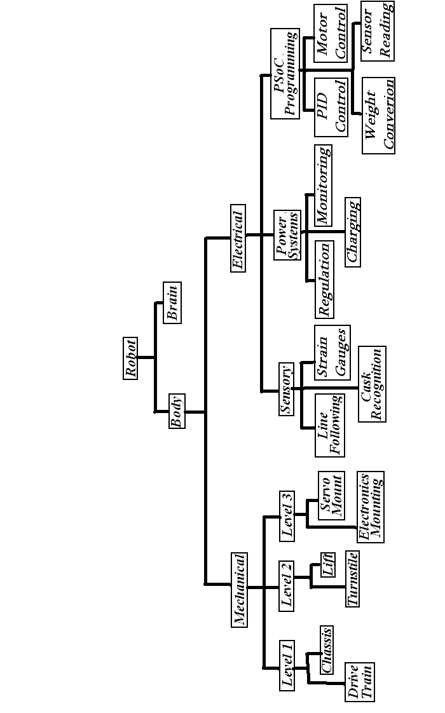
FIGURE 10.1
Line Following Block Diagram
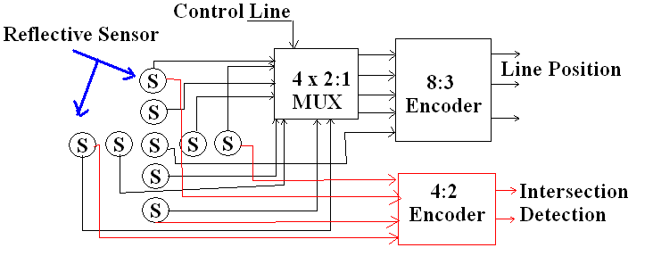
FIGURE 10.2
Power Regulation Block Diagram
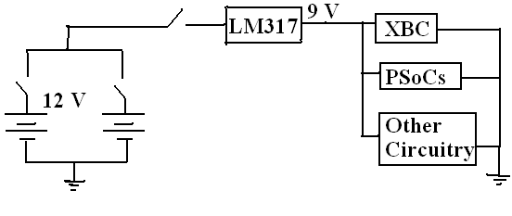
FIGURE 10.3
XI. APPENDIX B: Parts List With Cost Analysis

Part | Quantity | Cost | Worth | Total | Placement |  | Source
4202X Cat-Trak Transwheel | 4 | $21.11 | $21.11 | $84.44 | Drive Train |  | Kornylak Corp.
GHM-04 Gear Head Motor | 4 | $21.95 | $21.95 | $87.80 | Drive Train |  | Lynxmotion
Hub-12 Wheel Mounting Hub | 4 | $8.00/2 | $8.00/2 | $16.00 | Drive Train |  | Lynxmotion
Optical Encoder | 2 | $24.95 | $24.95 | $49.90 | Drive Train |  | Lynxmotion
Optical Encoder | 2 | $0.00 | $24.95 | $49.90 | Drive Train |  | 06-07 Robot
Bronze Sleeve | 4 | $2.87 | $2.87 | $11.48 | Drive Train |  | Lowe’s
MMT-02 Motor Mounting Bracket | 4 | $7.95/2 | $7.95/2 | $15.90 | Chassis |  | Lynxmotion
3/8” U Aluminum | 44” | $5.42/48” | $5.42/48” | $5.42 | Chassis |  | Lowe’s
1/8”x1/2” Flat Aluminum | 35” | $6.32/6’ | $6.32/6’ | $6.32 | Chassis |  | Lowe’s
1” Corner Bracket | 12 | $1.57/4 | $1.57/4 | $3.14 | Chassis |  | Wal-Mart
0.5” Machine Screw | 24 | $0.83/11 | $0.83/11 | $2.49 | Chassis |  | Wal-Mart
0.5” Flat Washer | 24 | $0.83/11 | $0.83/11 | $2.49 | Chassis |  | Wal-Mart
0.5” Lock Washer | 24 | $0.83/11 | $0.83/11 | $2.49 | Chassis |  | Wal-Mart
Omega Strain Gauge | 4 | $.000 | $4.50 | $18.00 | Lift |  | Supplied by ECE Department
Legos | N/A | $0.00 | $20.00 | $20.00 | Lift |  | Supplied by CS Department
GHM-04 Gear Head Motor | 2 | $0.00 | $21.95 | $43.90 | Turnstile |  | 06-07 Robot
12”x24” Wood Sheet | 1 | $5.99 | $5.99 | $5.99 | Turnstile |  | Michaels
1/16”x1/2” Flat Aluminum | 68” | $4.93/6’ | $4.93/6’ | $4.93 | Turnstile |  | Lowe’s
5/8” Slotted Aluminum | 32” | $0.00 | $6.49/6’ | $6.49 | Turnstile |  | Donated
1.5” L Corner Bracket | 6 | $1.78/4 | $1.578/4 | $3.56 | Turnstile |  | Wal-Mart
1” Corner Bracket | 8 | $1.57/4 | $1.57/4 | $3.14 | Turnstile |  | Wal-Mart
4” Mending Brace | 2 | $0.88/2 | $0.88/2 | $0.88 | Turnstile |  | Wal-Mart
6” Mending Brace | 1 | $1.97 | $1.97 | $1.97 | Turnstile |  | Wal-Mart
2” Mending Brace | 2 | $0.88/4 | $0.88/4 | $0.88 | Turnstile |  | Wal-Mart
0.5” Machine Screw | 20 | $0.83/11 | $0.83/11 | $0.83 | Turnstile |  | Wal-Mart
1” Machine Screw | 10 | $0.83/10 | $0.83/10 | $0.83 | Turnstile |  | Wal-Mart
0.5” Flat Washer | 30 | $0.83/11 | $0.83/11 | $2.49 | Turnstile |  | Wal-Mart
0.5” Lock Washer | 30 | $0.83/11 | $0.83/11 | $2.49 | Turnstile |  | Wal-Mart
Large Red Rocker Switch | 1 | $0.60 | $0.60 | $0.60 | Power Systems |  | All Electronics
Small Slide Switch | 2 | $0.00 | $0.30 | $0.60 | Power Systems |  | 06-07 Robot
12 V Wall Transformer | 1 | $6.75 | $6.75 | $6.75 | Power Systems |  | All Electronics
2.1mm Power Jack | 1 | $0.35 | $0.35 | $0.35 | Power Systems |  | All Electronics
2 Position Terminal Block | 2 | $0.45 | $0.45 | $0.90 | Power Systems |  | All Electronics
4 AA Battery Holder | 2 | $1.10 | $1.10 | $2.20 | Power Systems |  | All Electronics
LM 317 Voltage Regulator | 2 | $2.29 | $2.29 | $4.58 | Power Systems |  | RadioShack
2800 mAh AA Battery | 8 | $22.50/10 | $22.50/10 | $22.50 | Power Systems |  | East Coast Trading
2800 mah 7.2 V Battery | 2 | $0.00 | $24.95 | $49.90 | Power Systems |  | 06-07 Robot
0.1” Male Headers | 10 | $1.70/10 | $1.70/10 | $1.70 | Circuitry Interface |  | Jameco Robot Store
0.1” Male Headers | 10 | $2.11/10 | $2.11/10 | $2.11 | Circuitry Interface |  | Jameco Robot Store
0.1” Male Headers | 10 | $2.00/10 | $2.00/10 | $2.00 | Circuitry Interface |  | Jameco Robot Store
10 Pin Connector | 1 | $2.90 | $2.90 | $2.90 | Circuitry Interface |  | All Electronics
8 Pin Connector | 2 | $1.75 | $1.75 | $3.50 | Circuitry Interface |  | All Electronics
2x6 Row Male Header | 4 | $0.25 | $0.25 | $1.00 | Circuitry Interface |  | All Electronics
2x12 Row Male Header | 3 | $0.40 | $0.40 | $1.20 | Circuitry Interface |  | All Electronics
2x40 Row Male Header | 1 | $1.25 | $1.25 | $1.25 | Circuitry Interface |  | All Electronics
¾” Nylon Supports | 20 | $0.50/10 | $0.50/10 | $1.00 | Circuitry Mounting |  | All Electronics
Optical Interrupter | 2 | $0.50 | $0.50 | $1.00 | Monitoring Sensory |  | All Electronics
IR Cable | 4 | $1.95 | $1.95 | $7.80 | Cask Detection |  | Lynxmotion
Rangefinder | 4 | $0.00 | $14.95 | $59.80 | Cask Detection |  | Supplied by CS Department
QRD-1114 Reflective Sensor | 20 | $0.49 | $0.49 | $9.80 | Line Following |  | Fairchild Semiconductor
HS-422 Servo | 2 | $0.00 | $10.00 | $20.00 | Camera Pan |  | 06-07 Robot
276-168B PC Board | 1 | $3.49 | $3.49 | $3.49 | Motor Control Circuit |  | RadioShack
276-1998  16 Pin Socket | 6 | $1.29 | $1.29 | $7.74 | Motor Control Circuit |  | RadioShack
L293D Motor Driver IC | 6 | $0.00 | $2.75 | $16.50 | Motor Control Circuit |  | Supplied by ECE Department (Digikey)
Parallax 27976 LCD Display | 1 | $29.95 | $29.95 | $29.95 | PSoC |  | Jameco Robot Store
CY3210-PSoCEVAL1  PSoC | 2 | $0.00 | $68.99 | $137.98 | PSoC |  | Supplied by ECE Department
XBC V2 Robot Controller | 1 | $0.00 | $322.00 | $322.00 | High Level Control |  | Supplied by CS Department
Game Boy Advance | 1 | $0.00 | $150.00 | $150.00 | High Level Control |  | Supplied by CS Department
 |  |  |  |  |  | Total Cost: $430.18
 |  |  |  |  |  | Net Worth: $1306.85

Table 11.1

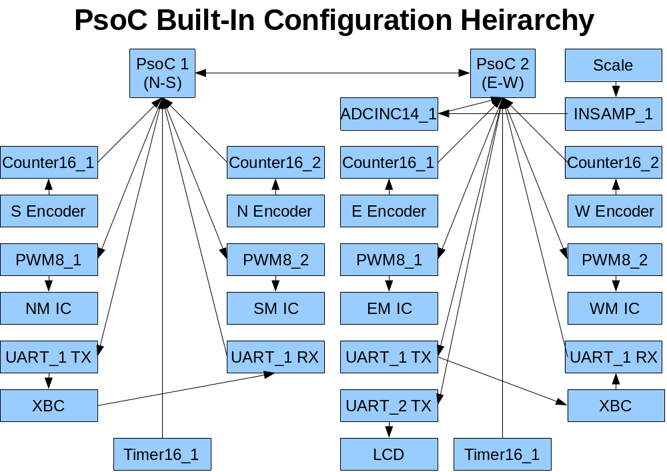
XII. APPENDIX C: PSoC Flowcharts and Diagrams

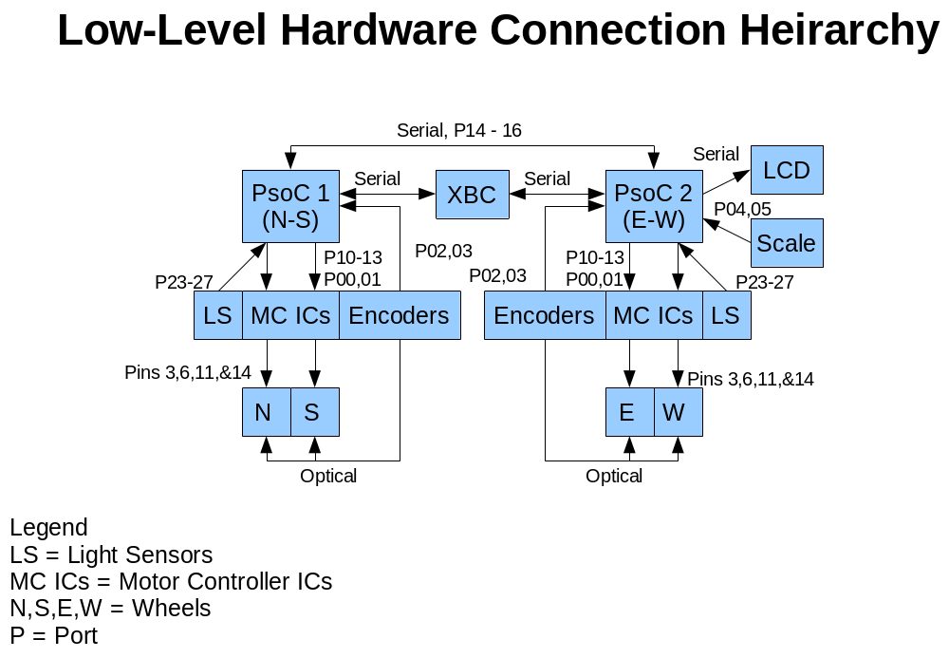
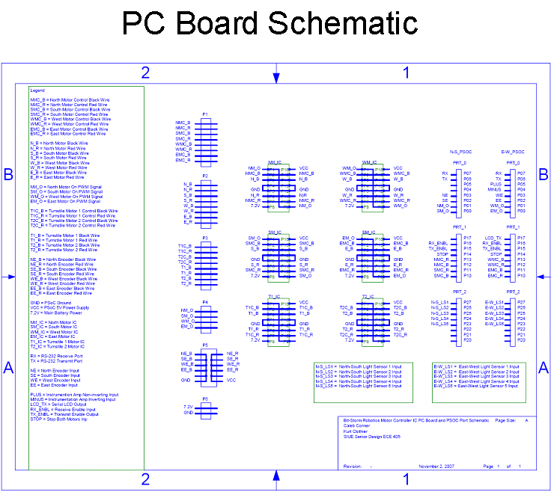

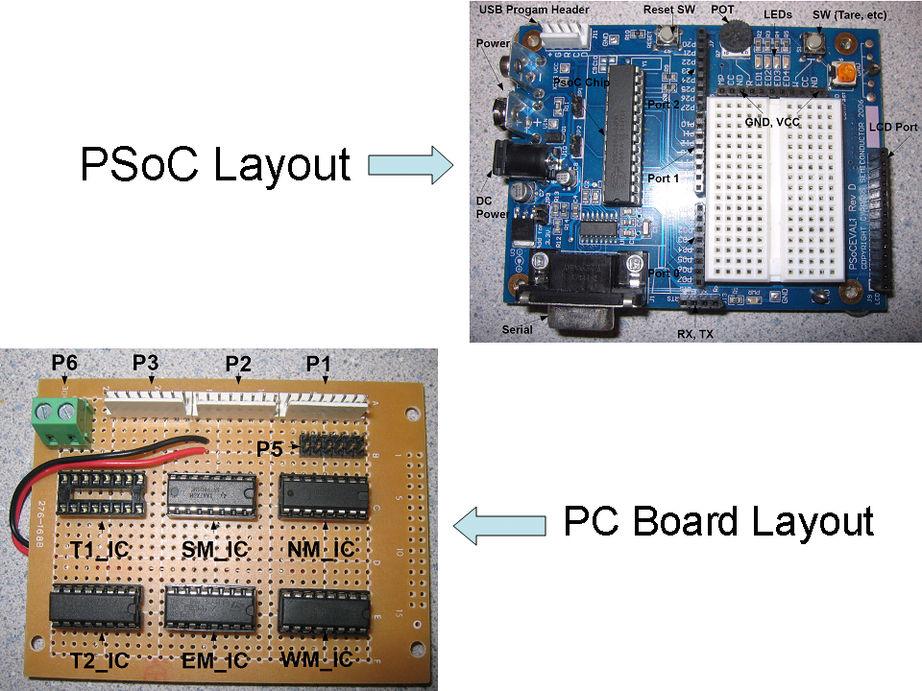
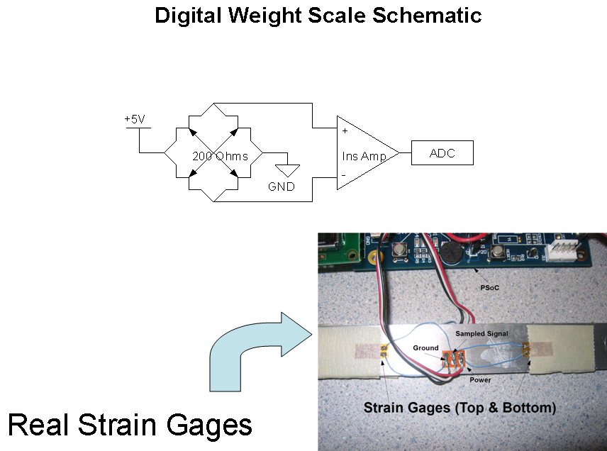

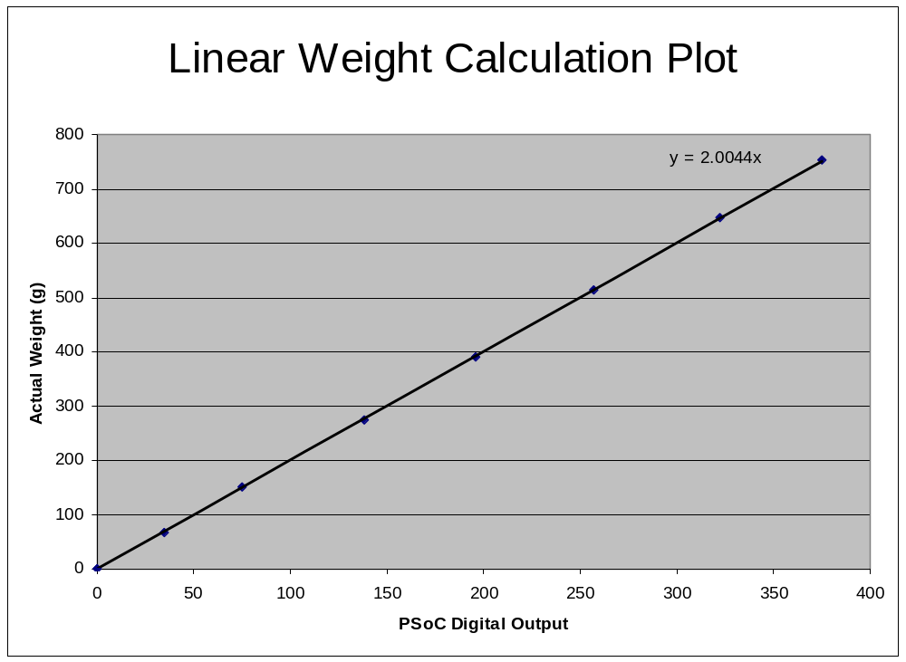
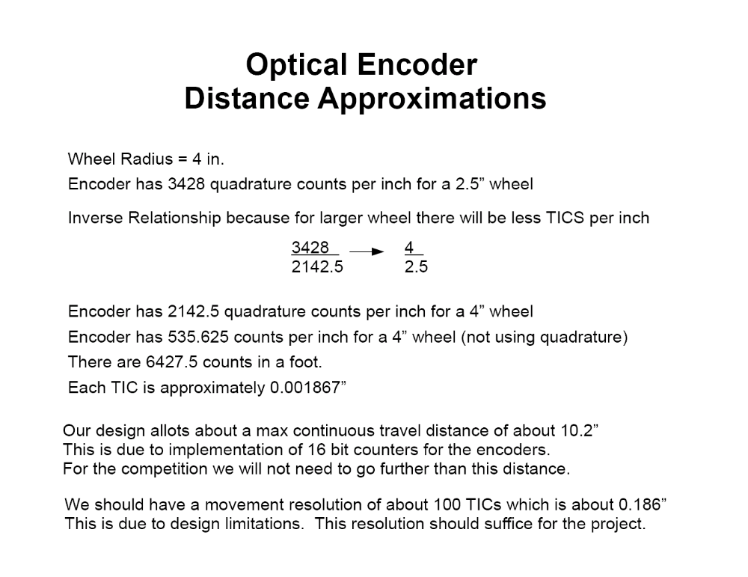
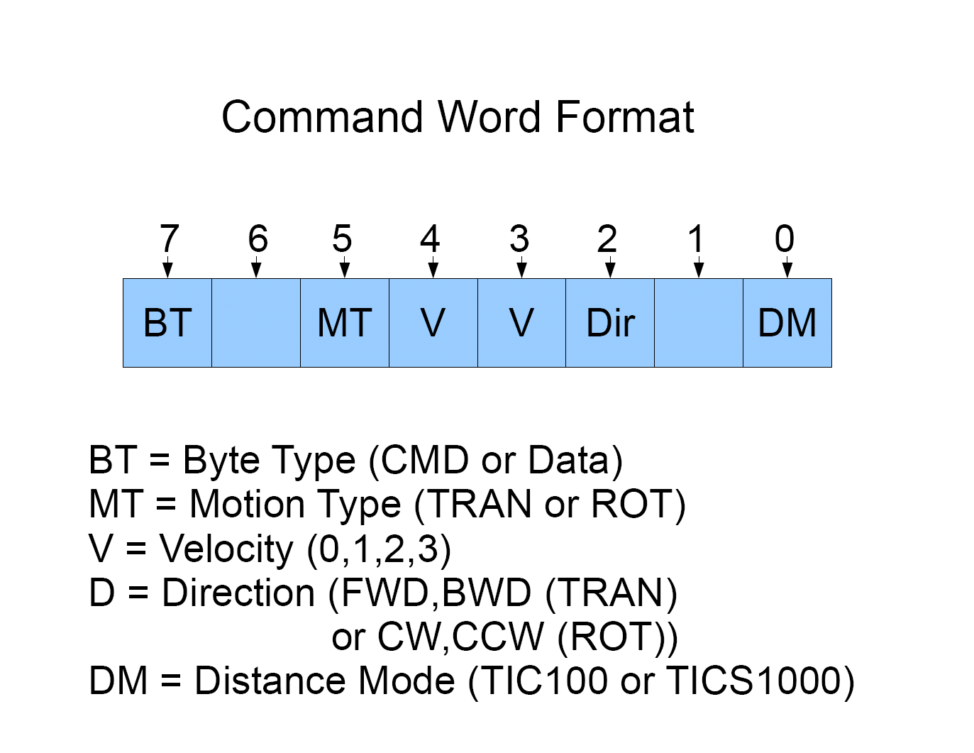
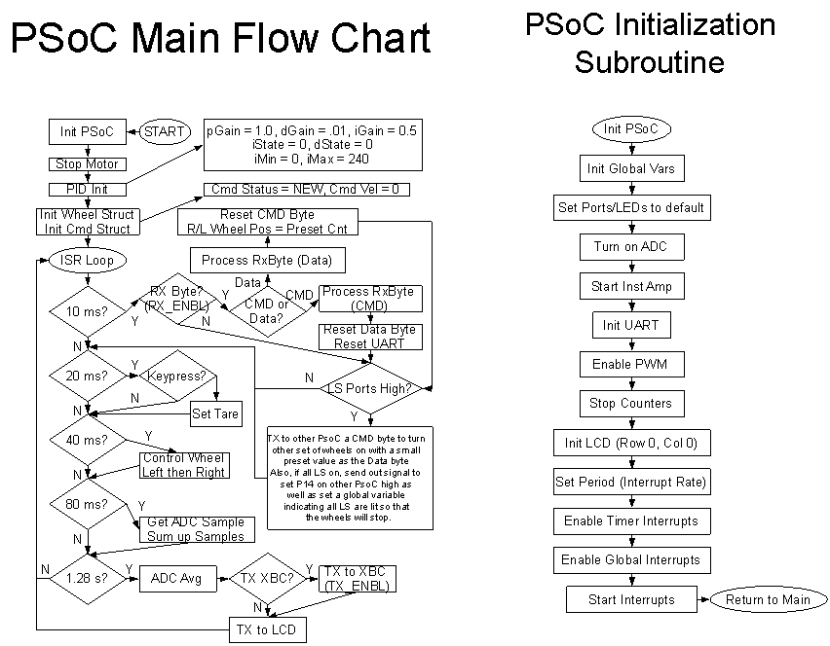
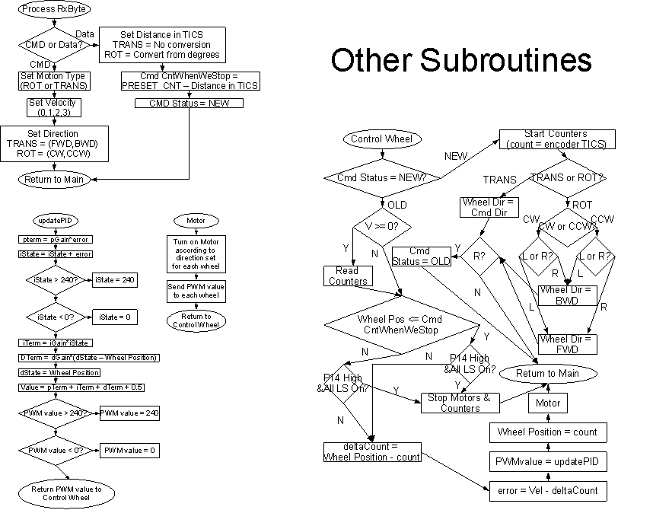
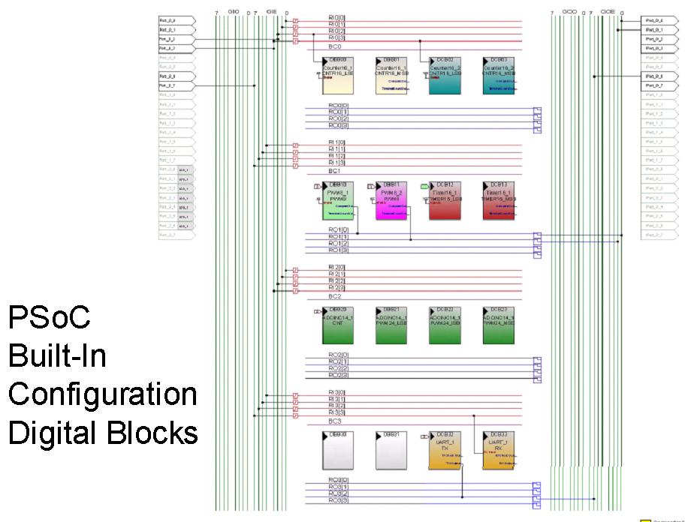
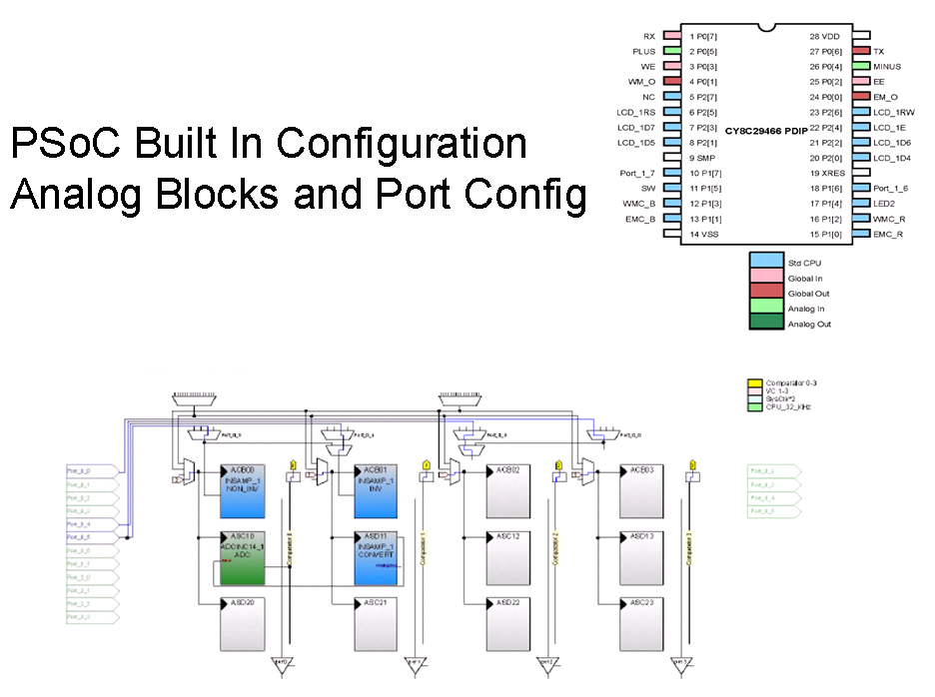

XIII. APPENDIX C: References

Coulston, Chris S., Ford, Ralph M. Design for Electrical and Computer Engineers. Chapter 3: The Requirements Specification. McGraw Hill Companies, Inc. 2005.
Ronan, Bob. 2008 IEEE Region 5 Technical, Professional, and Student Conference. Robotics Competition Rules. 2007. http://ewh.ieee.org/conf/basics2/2008-Rules-0.php.

